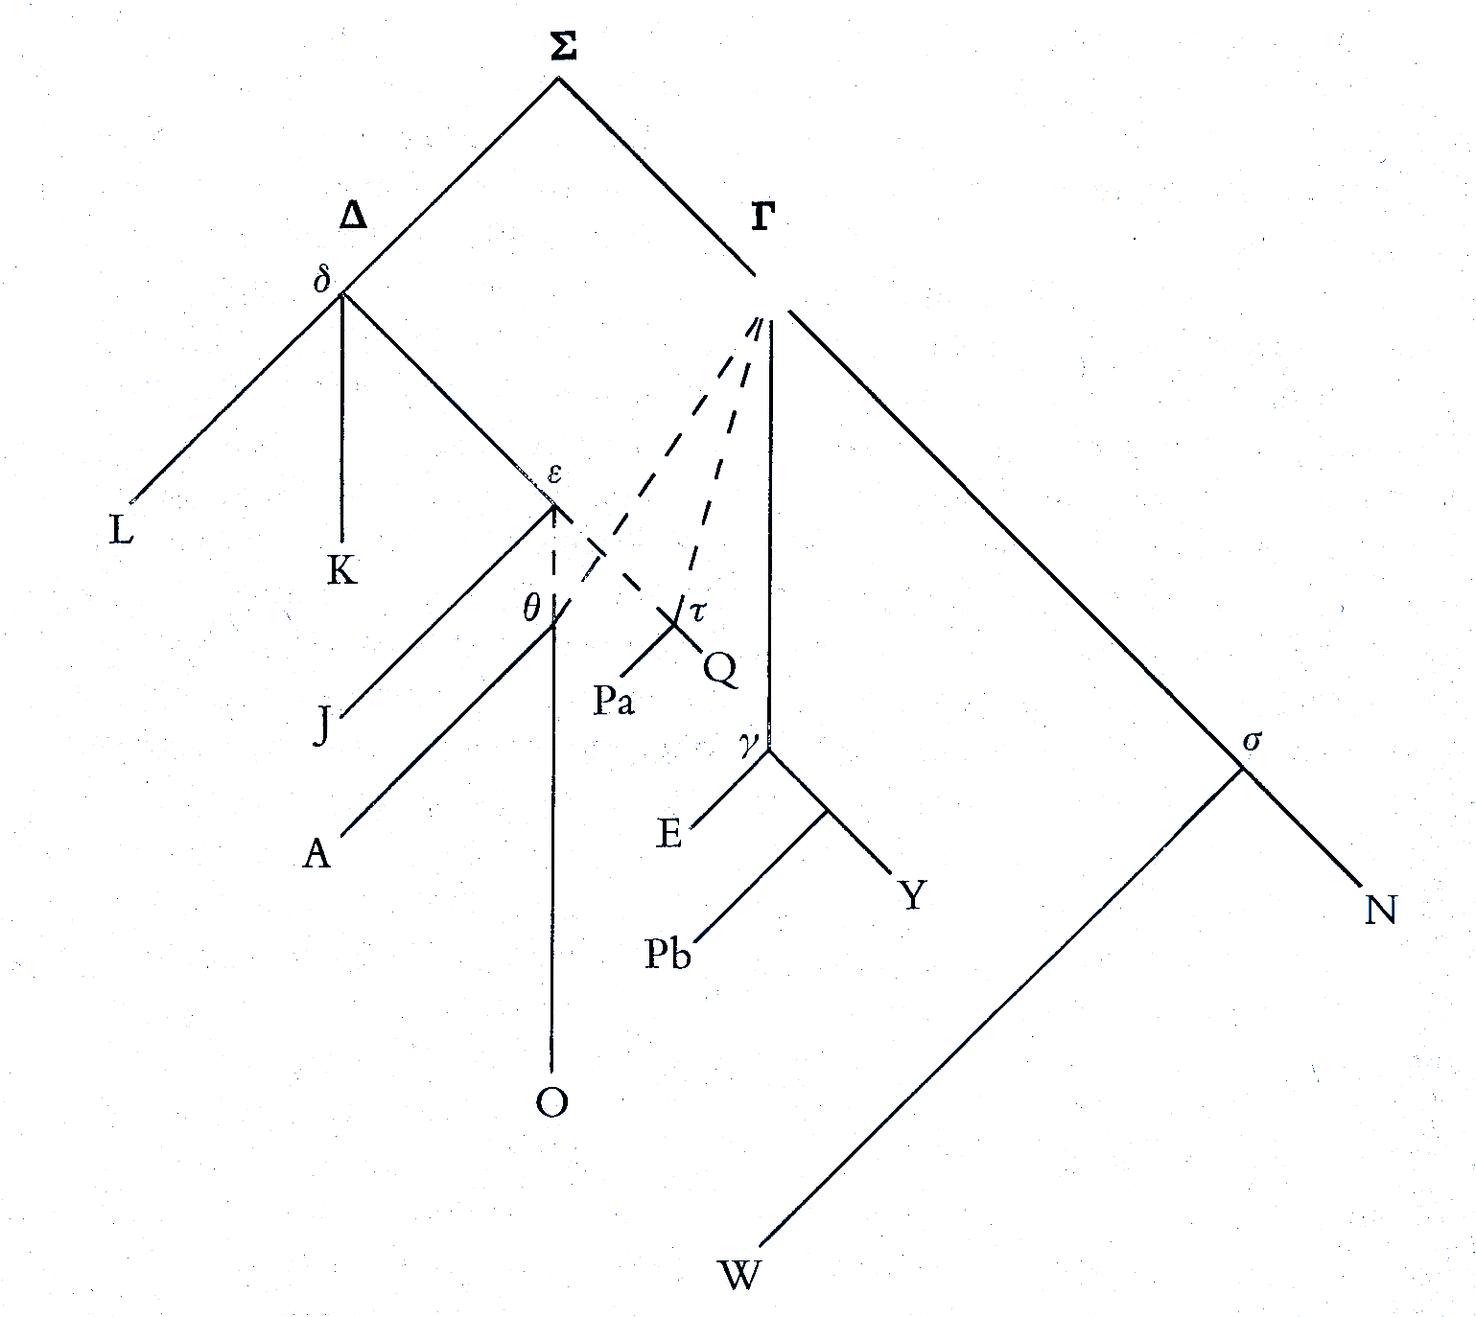

Figure 1. Tentative Stemma of the Main Manuscripts of Servius (**Σ**)